**Graph Theory and its Applications**

**Assignment 4**

**Restaurant Recommender System**

Name : Sanmat Sanjayakumar Payagoudar

SRN : PES1UG20CS385

**About the Dataset :**

For building the Restaurant Recommender System we use 8 main datasets

* Cuisine.csv
* Location.csv
* Person.csv
* Restaurant.csv
* Is_friend_of.csv
* Likes.csv
* Located.csv
* Serves.csv

**Creating Nodes**

1. **Cuisine**

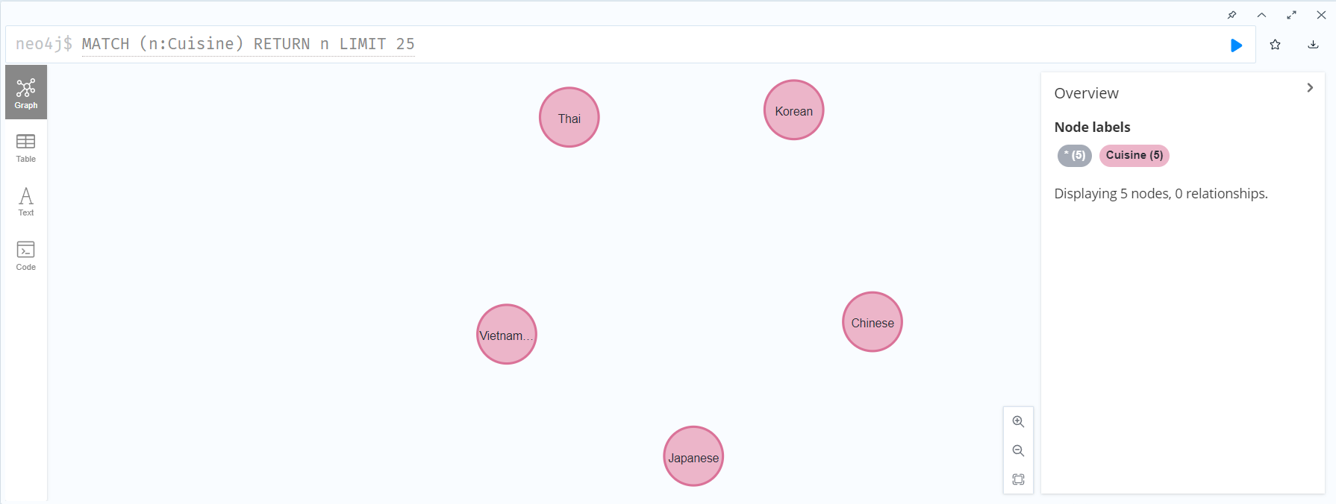

1. **Location**

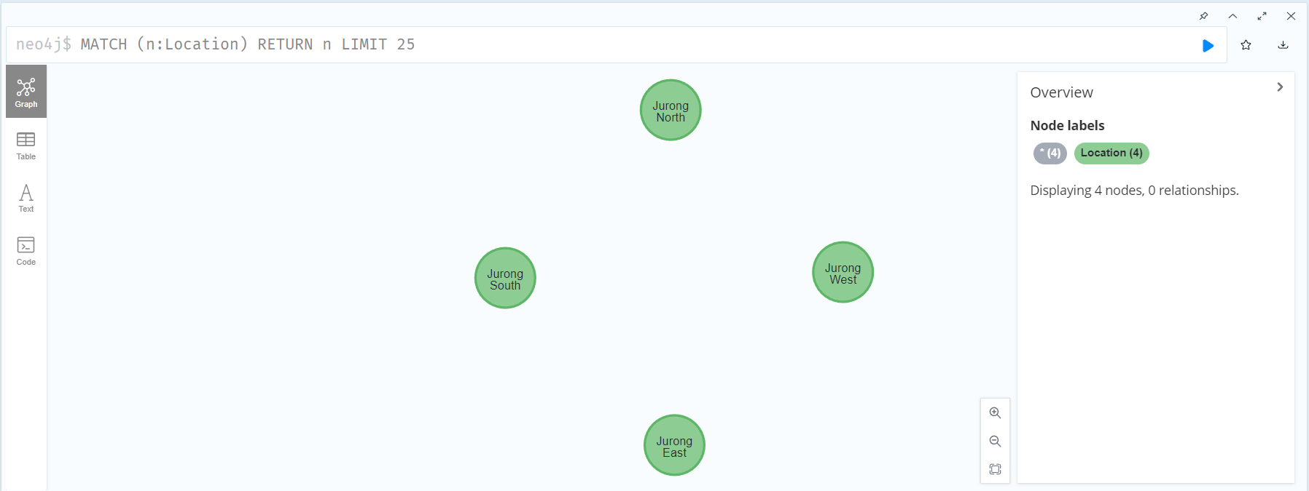

1. **Person**

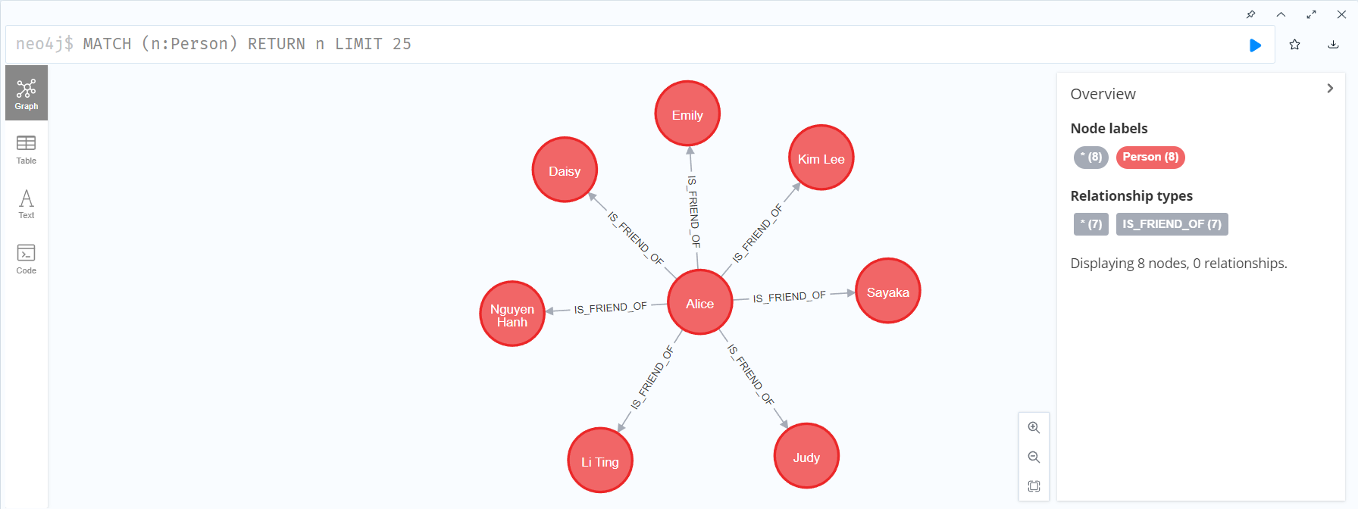

1. **Restaurant**

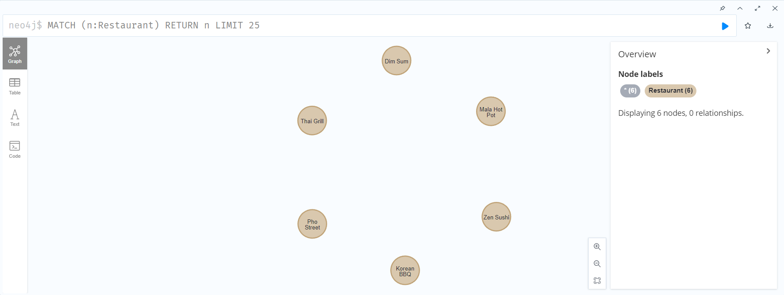

**Creating Relation**

1. **Is_friend_of**

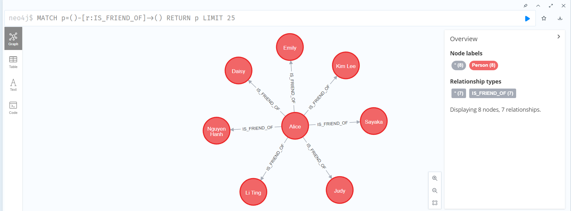

1. **Likes**

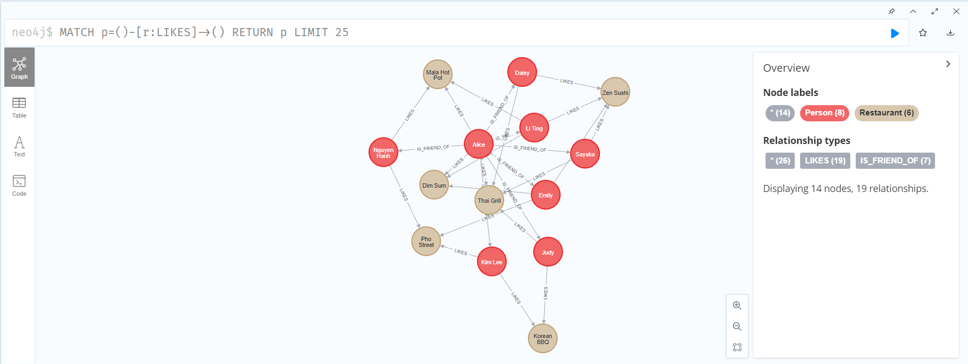

1. **Located_in**

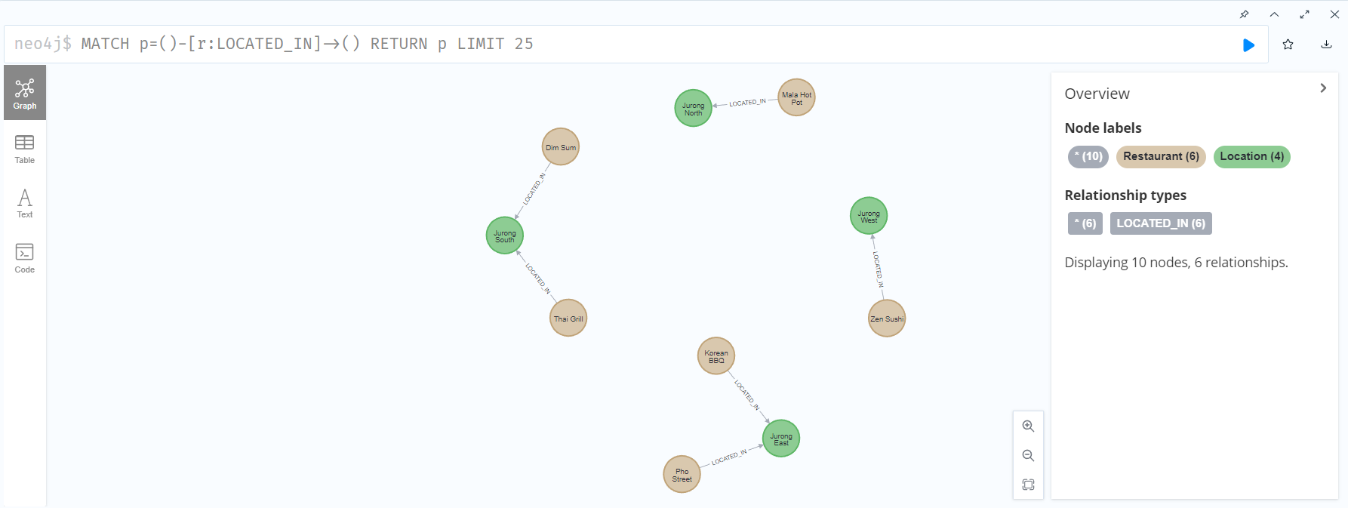

1. **serves**

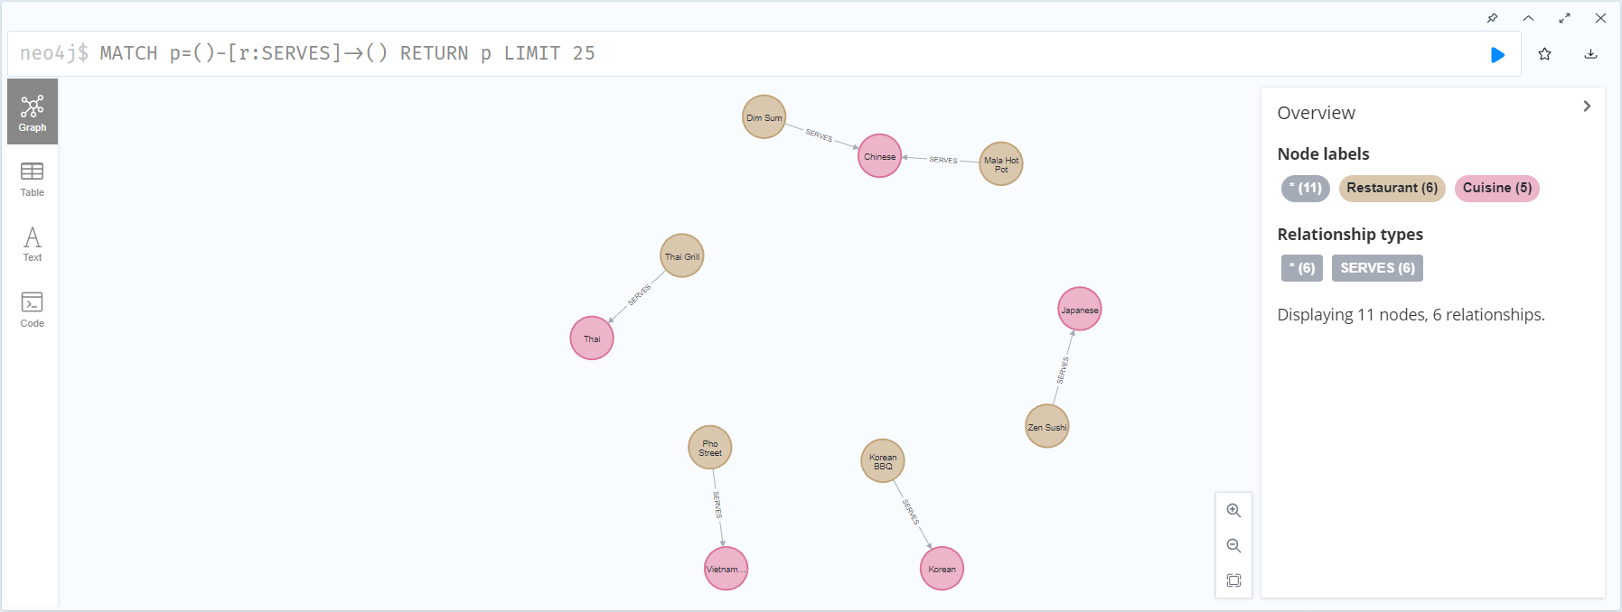

**Whole Graph**

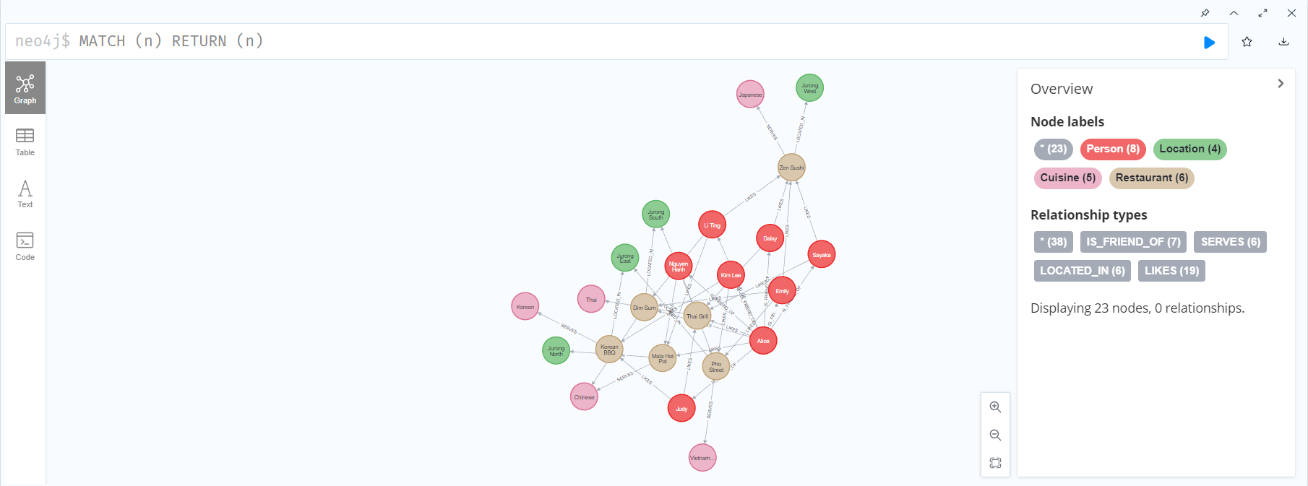

**Content Based Filtering :**

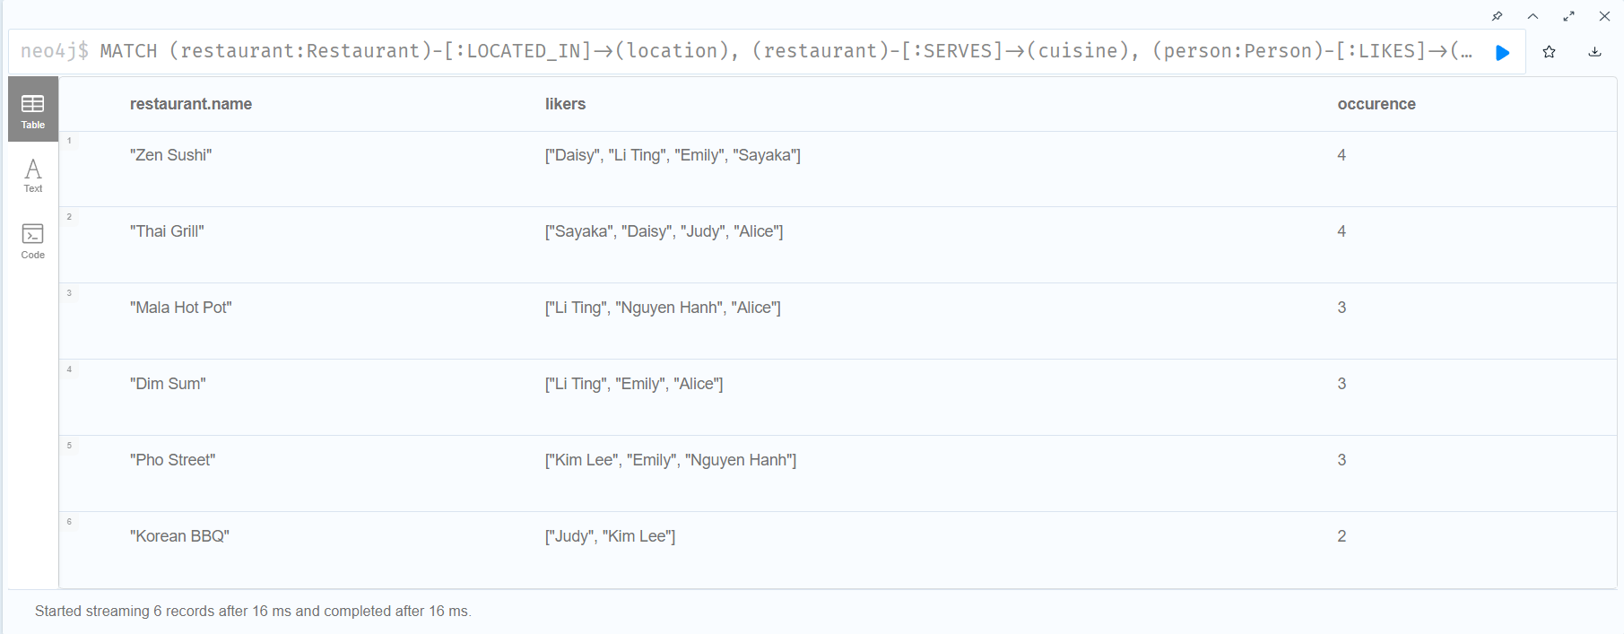

**Collaborative Filtering :**

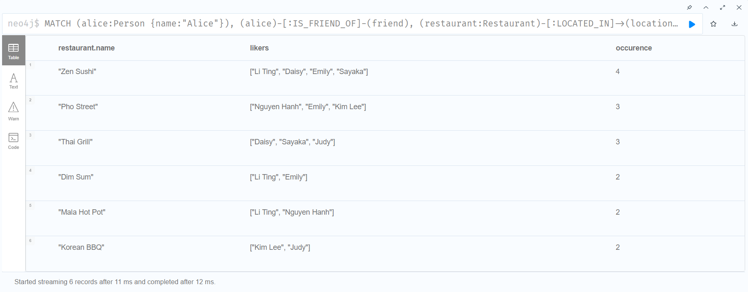

**Betweenness Centrality:**

